MINI F56 (2014 – onwards) ADJUSTABLE REAR TIE-BARS
INSTALLATION INSTRUCTIONS
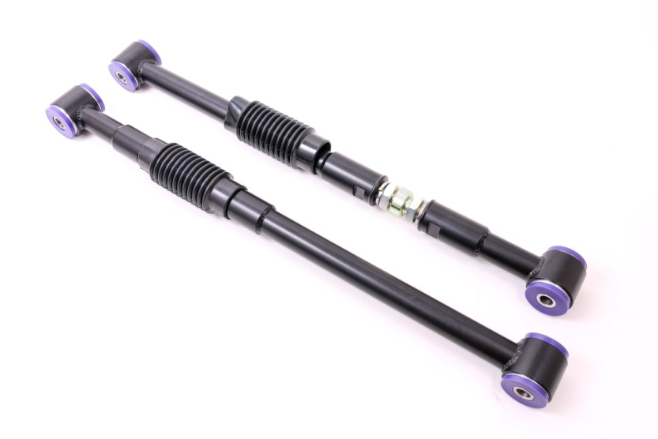
Please thoroughly read through and familiarize yourself with these instructions in their entirety prior to beginning any part of the installation process of any component. Please also ensure the vehicle and engine has cooled down sufficiently to avoid risking possible skin burns or other injury.
Tools Required:
- Access to vehicle lift or floor jack and axle stands to support the vehicle.
- 8mm socket, short extension bar and suitable ratchet.
- E14 Torx socket and suitable ratchet.
- 18mm spanner.
- Large adjustable spanner.
- Paint marker or cold chisel.
- Transmission jack or similar.
Engineered for performance
- Raise the vehicle on a ramp or suitable axle stands, to allow access to the underside of the car.

- Support the weight of the rear wheel and suspension using a transmission jack or similar

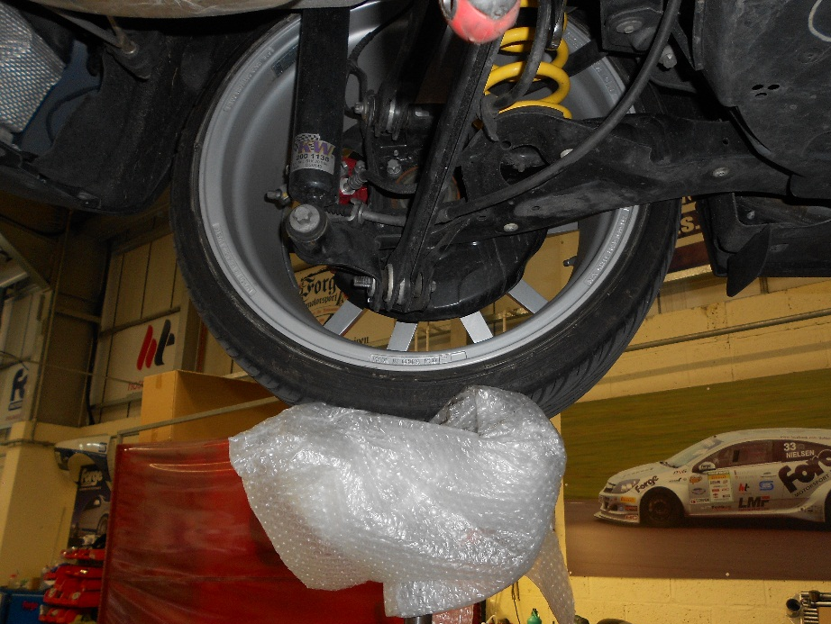

- Using an 8mm socket, short extension bar and suitable ratchet undo 3x bolts and remove the plastic guards on both sides.

Engineered for performance
- Using a paint marker, centre dot or cold chisel mark the position of the snail adjuster.

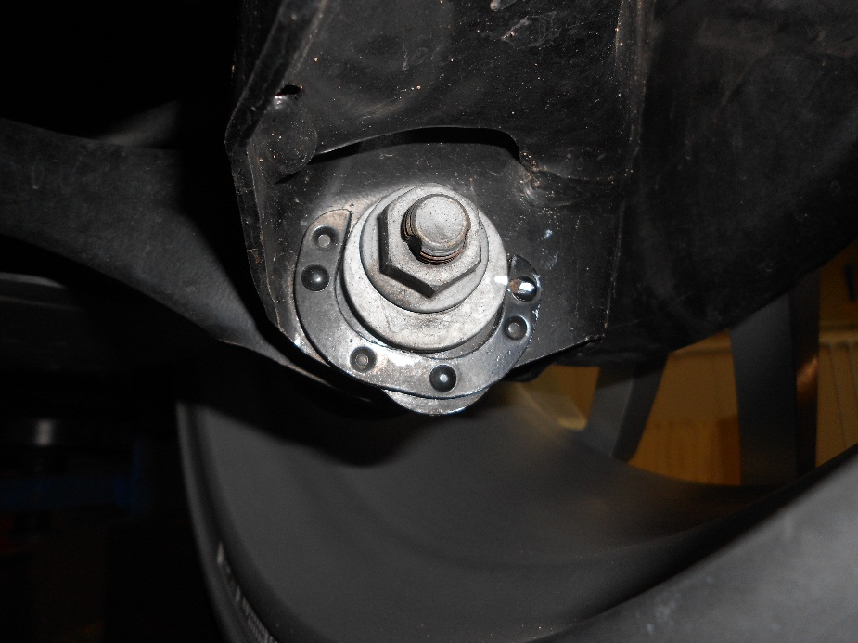

- Using an E14 Torx socket, suitable ratchet and 18mm spanner undo the top bolt and remove it.

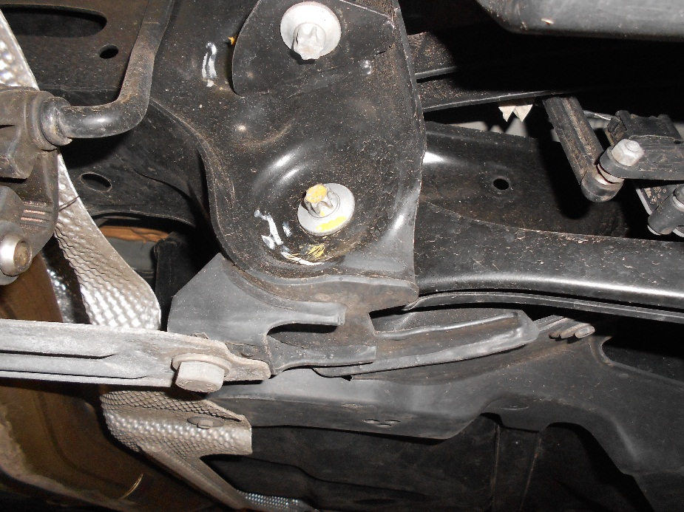

Engineered for performance
- Using an E14 Torx socket, suitable ratchet and 18mm spanner undo the lower bolt. Carefully remove the snail adjuster plate and bolt.

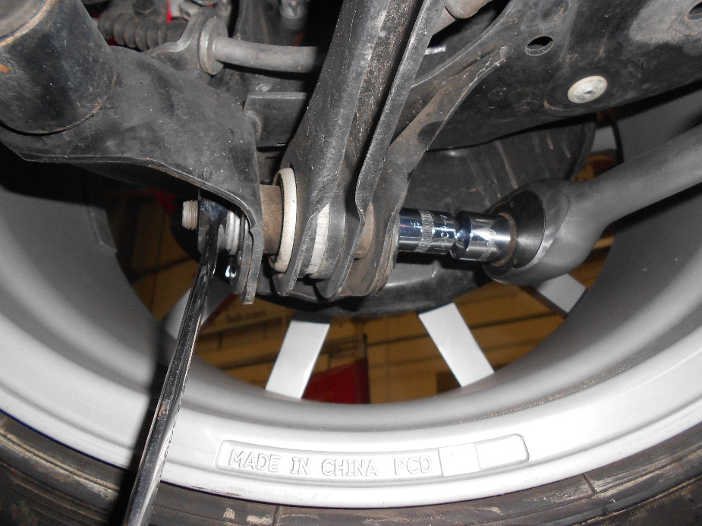

- Place a piece of packing material between the lower part of the tie bar and the wheel. Pull the tie-bar downwards to release it.
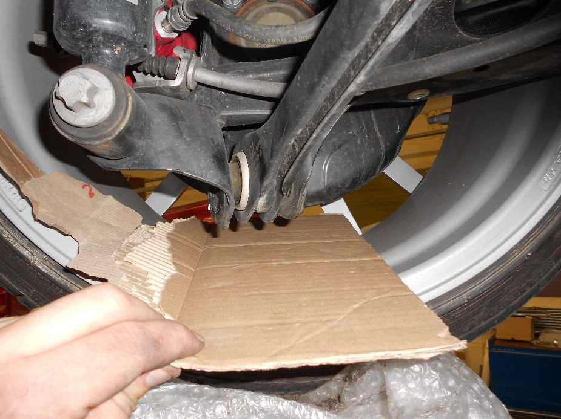
Engineered for performance
- Using the standard tie-bar and OEM bolts match the bolt hole centres on your Forge adjustable tie-bars. This is just to set a baseline you will need to get the tracking checked after the installation is completed. Using a pair of adjustable spanners lock both locking nuts when the tie-bar are set at the correct length.

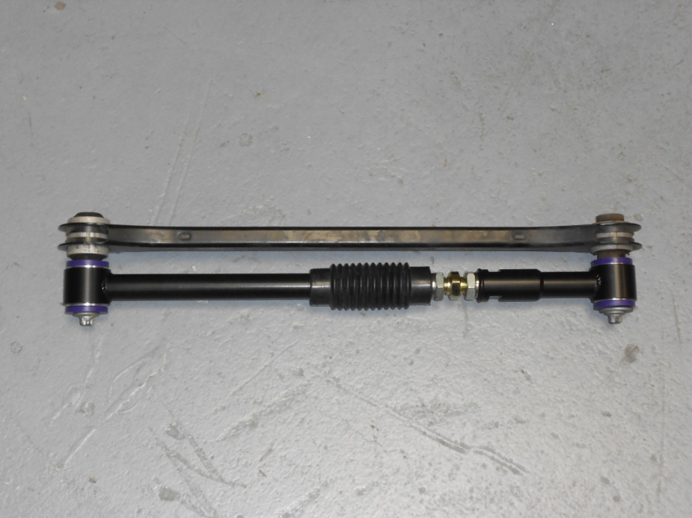

- Reinstall your Forge tie-bar in the reverse of the disassembly. The short side of the tie bar fits closest to the wheel hub.

- Insert the chassis end first and replace the nut and bolt. Do not fully tighten.
Engineered for performance
- Push the wheel outwards to allow the other end of the tie- bar to push into position.

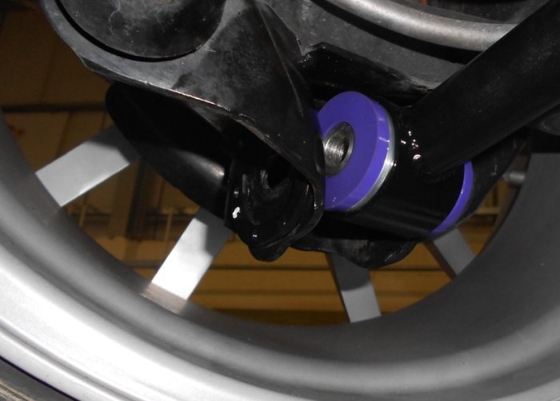

- Re-install the snail adjuster, bolt and nut.

- Rotate the snail adjuster in the position marked during disassembly and fully tighten the bolt.

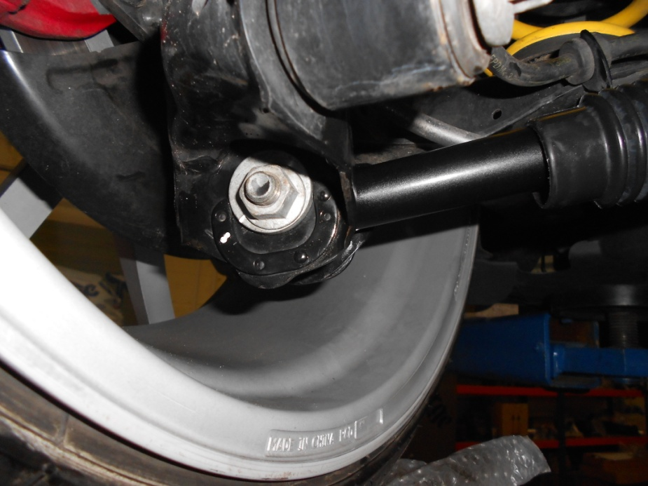

Engineered for performance
- Fully tighten the top bolt.

- Double check that both locking nuts are fully tightened on both tie-bars, slide the rubber covers into position and secure the cable ties supplied, trim off excess any cable tie.
- We advise that you have the vehicle tracking checked after installation.

- Your installation should now be complete. Enjoy Your New Performance!
Check out WWW.FORGEMOTORSPORT.CO.UK and WWW.FORGEMOTORSPORT.COM
For a full range of performance products for your vehicle.
As always, with any questions or concerns about this product or anything else, please feel free to contact your local or preferred Forge Motorsport Dealer/ Installer, or you may contact us directly.
Forge Motorsport UK – (+44)1 452 380 999 / info@forgemotorsport.co.uk
Forge Motorsport US – (407)-447-5363 / sales@forgemotorsport.com

Engineered for performance

